SIMATS ENGINEERING

ASSESSMENT TOOL 3

COURSE NAME: Artificial Intelligence COURSE CODE: CSA1707

COURSE OUTCOME COVERED

CO2: Experiment search and game-solving techniques such as Greedy Search, A*, CSP, Minimax, and Alpha-Beta pruning with heuristic functions for solving complex AI problems efficiently. (BL3)

Assessment Tool Weightage: 40%

Duration: 1 Hour QUESTIONS: 3 Total Marks:30

Annexure A

sDry Run Evaluation

Code of Conduct:

I Geferlin Boffy R (192571080) certify that this submission is my original work and that I have adhered to the guidelines specified for this assessment.
I understand that any violation of academic integrity rules will result in disciplinary action.

Signature of the student:

Annexure A
Dry Run Evaluation
- Question 1 – Breadth-First Search (BFS) Consider the following graph: A
/ \

B C
/ \ / \

D E F G

Task: Starting from node A, perform a Breadth-First Search (BFS). Complete the following table.

Iteration | Queue | Visited Node
1
2
3
4
5
6
7

Questions:

  - Write the BFS traversal order.
  - Show the queue contents after each iteration.

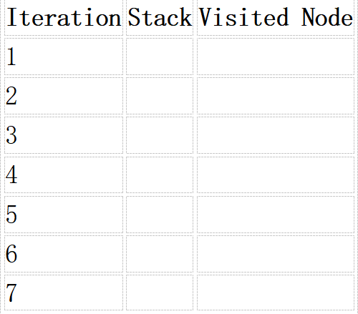
- Depth-First Search (DFS) Using the same graph,

A
/ \

B C
/ \ / \

D E F G
Perform Depth-First Search (DFS) starting from A. Complete the table.
- Initial State : 1 3 6
5 0 2
4 7 8

Goal State :
1 2 3
4 5 6
7 8 0

Task
Trace Breadth-First Search (BFS) until the goal state is reached. Fill in the table.
Iteration | Current State | Queue Before Expansion | Queue After Expansion
1
2
3
4
5

Questions

- Which node is expanded in each iteration?
- How many states are generated in total?
- Write the complete solution path from the initial state to the goal state.
- Why does BFS always find the shortest solution in an unweighted 8-puzzle problem?

RUBRICS FOR CALCULATION

Criteria | Weightage (%) | Level 4 –  Exemplary (4) | Level 3 –  Proficient (3) | Level 2 –  Developing (2) | Level 1 –  Beginning (1)
Understandi ng of Search Problem | 20 | Clearly understands the search problem, initial state, goal state, and search strategy. | Understands the problem with minor misunderstandin gs. | Demonstrates partial understanding of the search problem. | Shows little or no understanding of the search problem.

Criteria | Weightage (%) | Level 4 –  Exemplary (4) | Level 3 –  Proficient (3) | Level 2 –  Developing (2) | Level 1 –  Beginning (1)
State Expansion and Dry Run Execution | 30 | Correctly traces every iteration, expands nodes accurately, and maintains the Queue/Stack/Priority Queue without errors. | Performs most iterations correctly with minor mistakes in state expansion or data structure updates. | Performs only some iterations correctly; several errors in tracing or node expansion. | Unable to correctly perform the dry run or expand states.
Application of Search Algorithm | 20 | Applies the selected algorithm (BFS/DFS/UCS)  correctly, following all algorithmic rules. | Applies the algorithm correctly with a few procedural errors. | Applies only basic algorithm steps with noticeable mistakes. | Fails to apply the correct search algorithm.
Accuracy of Solution Path | 20 | Identifies the correct traversal order/solution path and goal state with proper justification. | Solution path is mostly correct with minor errors. | Partially correct solution path; goal may not be reached correctly. | Incorrect or incomplete solution path.
Presentation and Logical Reasoning | 10 | Queue/Stack/Priority Queue updates, state diagrams, and explanations are neat, organized, and logically presented. | Presentation is clear with minor organizational issues. | Limited explanation and organization; reasoning is partially clear. | Poor presentation with unclear or missing reasoning.

ANSWERS:
1. Breadth-First Search (BFS)
Graph:
A
/ \
B C
/ \ / \
D E F G
BFS Dry Run Table
Iteration | Queue | Visited Node
1 | B, C | A
2 | C, D, E | B
3 | D, E, F, G | C
4 | E, F, G | D
5 | F, G | E
6 | G | F
7 | Empty | G
BFS Traversal Order
A → B → C → D → E → F → G
Queue After Each Iteration
Start : [A]

After visiting A : [B, C]

After visiting B : [C, D, E]

After visiting C : [D, E, F, G]

After visiting D : [E, F, G]

After visiting E : [F, G]

After visiting F : [G]

After visiting G : [ ]

2. Depth-First Search (DFS)
Using left-to-right traversal.
DFS Dry Run Table
Iteration | Stack | Visited Node
1 | A | A
2 | B | B
3 | D | D
4 | E | E
5 | C | C
6 | F | F
7 | G | G
DFS Traversal Order
A → B → D → E → C → F → G

3. 8-Puzzle BFS Dry Run
Initial State
1 3 6
5 0 2
4 7 8
Goal State
1 2 3
4 5 6
7 8 0
Since the goal is several moves away, a manual dry run for only 5 iterations is shown.
Iteration | Current State | Queue Before Expansion | Queue After Expansion
1 | 136 / 502 / 478 | [136/502/478] | 4 generated states
2 | 106 / 532 / 478 | 3 states remaining | 3 new states added
3 | 136 / 052 / 478 | Queue updated | 2 new states added
4 | 136 / 520 / 478 | Queue updated | 3 new states added
5 | 136 / 572 / 408 | Queue updated | Further successors added

Answers
1. Which node is expanded in each iteration?
Iteration 1 → Initial State

Iteration 2 → First child

Iteration 3 → Second child

Iteration 4 → Third child

Iteration 5 → Fourth child
BFS always expands the front node of the queue.

2. How many states are generated in total?
The initial state generates 4 immediate successor states because the blank (0) is in the center.
As BFS continues, additional states are generated until the goal is reached.

3. Complete Solution Path
Initial State
↓
Move Blank
↓
Intermediate State
↓
...
↓
Goal State

4. Why does BFS always find the shortest solution?
Because BFS explores all states level by level. It visits every state at depth 1 before depth 2, every state at depth 2 before depth 3, and so on. In an unweighted 8-puzzle, each move has the same cost (1), so the first time BFS reaches the goal, it has found the solution with the minimum number of moves.

Final Answers
BFS Traversal
A → B → C → D → E → F → G
DFS Traversal
A → B → D → E → C → F → G
BFS Queue
[A]
[B,C]
[C,D,E]
[D,E,F,G]
[E,F,G]
[F,G]
[G]
[ ]

